Amazon Data Rating Review Analysis and Predicting

Abstract:

Sentiment analysis is one of the fastest spreading research areas in computer science, making it challenging to keep track of all the activities in the area. We present a customer feedback reviews on product, where we utilize opinion mining, text mining and sentiments, which has affected the surrounded world by changing their opinion on a specific product. Data used in this study are online product reviews collected from http://Amazon.com. We performed a comparative sentiment analysis of retrieved reviews.
Amazon data with collection of review text, product details, rating and review are taken as input. In the first step data analysis is performed from data based and graphical representation of each product, category, count, comparison is shown (rating, label vs rating, label vs product category, rating vs product category, verified purchases after analysis part is done. Testing training and prediction of rating from given review is performed in this process text processing, feature vectorization, feature extraction from text, cross validation, splitting data and training classifier steps are performed using machine learning and then algorithm (linear SVC algorithm) is applied to the review text and classifier is generated.
In prediction step when review as given and input prediction of rating is performed using Trained classifier and accuracy, Precision, Recall, f1-score is perfomed.

Existing system:
Conventionally, sentiment analysis has been about opinion contradiction, i.e., whether someone has positive, neutral, or negative opinion towards something. Auto detection of text and giving rating for given product was not performed in existing system
Disadvantages:
Opinion mining and positive and negative analysis was only done
Automatic prediction of rating from review with various analysis reports was not performed in existing system
Proposed system:
Machine learning techniques are used for preprocessing, vectorizing, classifier and features are extracted from dataset and prediction is performed for given review and accuracy of model is calculated.
Advantages:
Various data analysis factors are covered for product analysis.
Automatic rating calculation is done using machine learning classifer.

Architecture:
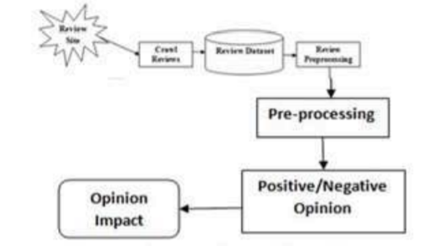

References:

- B. Liu, Handbook Chapter: Sentiment Analysis and Subjectivity, Handbook of Natural Language Processing, Handbook of Natural Language Processing, MarcelDekker, Inc.NewYork, NY, USA,2009
- K. Dave, S. Lawrence, and D. M. Pennock, “Mining the peanut gallery: Opinion extraction and semantic classification of product reviews,” in Proceedings of the 12th international conference on World Wide Web, 2003, pp. 519–528.
- Mugdha More and Bharat Tidke, July 2015. “A Framework For Summarization Of Online Opinion Using Weighting Scheme”, ACII, Vol.2, No.3.
- Haseena Rahmath P,” Opinion Mining and Sentiment Analysis Challenges and Applications”, IJAIEM Volume 3, Issue 5, May 2014.
- Muhammaad Zubair, Aurangzeb Khan, Shakeel Ahmad, Fazal Masud Kundi and Asghar, 2014. ”A Review of Feature Extraction in Sentiment Analysis”. ISSN 2090-4304 Journal of Basic and Applied Scientific Research.

